ACHEA CONFERENCE 2015 – CONFERENCE ACCOMMODATION
This is a list of available conference accommodation in the vicinity of The University of the West Indies, St. Augustine where the conference will be held.
HOTELS / BED AND BREAKFASTS / UWI HALLS OF RESIDENCE  (NOTE: BEFORE MAKING RESERVATIONS,  PLEASE PROVIDE THE CODE: ACHEA15) | RATES (Single/Double) | RATES  (Triple) | RATES  (Quad) | DISTANCE FROM CONFERENCE
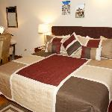  University Inn & Conference Centre – Conference Hotel  30 St. Augustine Circular Road, St. Augustine, Trinidad  Phone: 868-662-9635  Email: theuniversityinn@sta.uwi.edu  Website: http://www.theuniversityinn.com  Facebook: https://www.facebook.com/TheUniversityInn | $115 - $130  (taxes included) |  |  | 100 m
Holiday Inn Express Hotel & Suites  1 Exhibition Drive, Trincity  Hotel Front Desk: (868) 669-6209 / 669-6681  Hotel Fax: (868) 692-4557  Email: holidayinnexpress2@yahoo.com  Website: http://www.ihg.com/holidyinnexpress/hotels  /us/en/trincity/poshi/hoteldetail | $155 - $165  (taxes excluded) | $180  (taxes excluded) | $195  (taxes excluded) | 9.0 km
Regent Star Hotel  118-119 BWIA Boulevard, Piarco  Tel: 1-868-669-STAR (7827)  Fax: 1-868-669-7000  Email: info@regentstarhotel.com  Website: http://www.regentstarhotel.com/ | $135  (taxes excluded) | $175  (taxes excluded) | $175  (taxes excluded) | 8.2 km
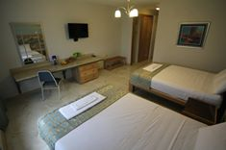  Shalom House Bed and Breakfast  24 Windsor Rd, Valsayn North, Trinidad  Tel: (868) 662-8624 / 662-862 / 740-7143 / 681-1466  Fax: (868) 696-0903  Email: pmorgan@tstt.net.tt  Facebook: www.facebook.com/shalomhousebb  Airbnb: https://www.airbnb.com/rooms/4740398 | $85 - $120  (taxes included) | $120 - $140  (taxes included) | $160  (taxes included) | 4.1 km
Norma’s Bed and Breakfast  2 Aruac Road, Valsayn South, Trinidad  Tel: (868) 645-9746 / 663-4137  Fax: (868) 645-0563  Email: normagabriel@hotmail.com  Website: http://www.normasbnb.com/ | $80 - $99  (taxes included) | $121  (taxes included) | $143  (taxes included) | 3.9 km
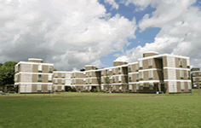  Canada Hall  The University of the West Indies  St. Augustine, Trinidad, W.I.  Tel.: 1-868-662-2002 Exts. 2386, 4286, 2497  Fax No.: 1-868-663-9684  Email: Warden@trinidad.net  Website: https://sta.uwi.edu/residence/canada.asp | $65  (taxes included) |  |  | 400 m
- Rates are quoted in US Dollars * Rates per night for the period 8 July – 12 July, 2015

