ACHEA CONFERENCE 2015 – ACCOMMODATION OPTIONS
This is a list of alternative accommodation in the vicinity of The University of the West Indies, St. Augustine and the Port of Spain area.
 | RATES (Single/Double) | RATES  (Triple) | RATES  (Quad) | DISTANCE FROM CONFERENCE
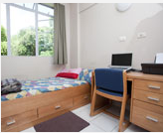  The Arthur Lewis Hall of Residence  St. John’s Road, St. Augustine  Telephone: (868) 662-9501  Fax: (868) 663-8407  Email: Kevin.snaggs@sta.uwi.edu  Website: https://sta.uwi.edu/residence/arthurlewis.asp | $25 - $45  (taxes included) |  |  | 2.3 km
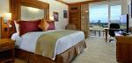  Hilton Trinidad and Conference Centre  Lady Young Road, Port of Spain  Tel: (868) 624-3211  Fax: (868) 624 4485; Guest Fax: (868) 623 9702  Email: reservations.trinidad@hilton.com  Website: http://www3.hilton.com/ | $149 - $179  (taxes excluded) | $209  (taxes excluded) | - | 16.3 km
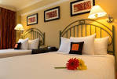  Kapok Hotel  16-18 Cotton Hill, St. Clair, Port of Spain  Tel: (868) 622 5765  Fax: (868) 622 9677  E-mail: stay@kapokhotel.com  Website: www.kapokhotel.com | $120 - $160  (taxes excluded) | - | - | 17.1 km
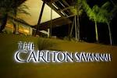  Carlton Savannah Hotel  2-4 Coblentz Ave, Port of Spain  Tel: (868) 621 5000  Fax: (868) 621 5001  Email: info@thecarltonsavannah.com  Website: http://www.thecarltonsavannah.com/ | $115 - $135  (taxes included) | - | - | 16.3 km
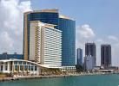  Hyatt Regency Trinidad  1 Wrightson Road, Port-of-Spain  Tel: (868) 623 2222  Fax: (868) 821 6401  Email: trirt.reservation@hyatt.com  Website: http://www.trinidad.hyatt.com/en/hotel/home.html | $179 - $199  (taxes excluded) | - | - | 14.8 km
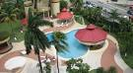  Radisson Hotel  Corner London St and Wrightson Road, Port of Spain  Tel: (868) 625-3366  Email: reservations@cplazahotel.com  Website: http://www.cplazatrinidad.com | $143 - $159  (taxes excluded) | - | - | 14.7 km

- Prices are quoted in US Dollars * Rates per night for the period 8 July – 12 July, 2015

